Records Excel Sheet
Before the creation of the noaarec.php file, I had come up with a way to maintain my own spreadsheet to contain the rain data, and normal/record temperature data. The Excel file then has macros to export all that information out into simple TXT files. Then I have my PHP code that pulls in today’s date, and opens the appropriate TXT files to display the data for today’s records. Since I’ve converted to using the noaaarec.php file, I’m only using the rain portion of my Excel file. But if your city doesn’t have a nearby WFO office that the noaarec.php file requires, you can accomplish the same results with this spreadsheet.
You will need to be fairly proficient with spreadsheets. I’ll be using Excel, but other applications should work. Most of the work will be a lot of copy/paste into the spreadsheet for the rain data. And manually entering in the temperature data. Once the spreadsheet is completed, once a year you may want to go back in and update any record high/low temperature data. From my experience, the National Weather service only updates the rain data every few years. So that won’t need to be updated as often.
Before you begin, Excel security will stop you from using the macros in the spreadsheet. First you will want to create a folder to work with. In Excel, go to File, Options, Trust Center, Trust Center Settings button. Change to Trusted Locations on the left pane. Click on Add new location button. Add in the new folder your created. Clikc on OK to close all the windows. I’ll be using the Bismarck, ND Data for my example.
- Download my Excel file here: https://www.bismarckweather.net/scripts/records.xlsm
- For rain data, you will only be working with column D.
- For temperature data, you will be working with columns G through L.
- Go to https://www.weather.gov
  - In the find box, enter in your city.
  - At the top, click on Past Weather, Records.
  - Click on the nearest WFO office. This will bring up the NOWData pages.
  - Click on your City in the 1. Location area.
- To start with, we need to gather the average rain for each day of the year. Have the records.xlsm spreadsheet open. But also open a new empty spreadsheet.
- On the NOWData page, have your city highlighted.
  - Change 2. Product to “Daily/monthly normals”
  - Change 3. Options to “Daily”
  - Change Variable to “Precipitation”
- Click on Go under 4. View.
- That will bring up a graph and a table.

- Scroll down to the table.
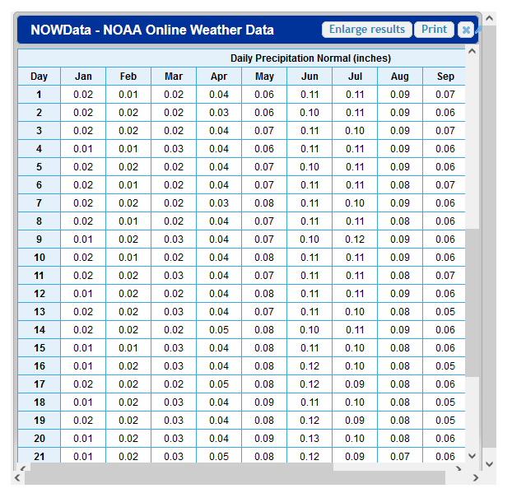
- You will need to start at the word DAY, using your mouse, highlight everything from DAY in upper left, down to the last rain data on December 31st. Then hit CONTROL-C on your keyboard to copy the data into your clipboard.
- Open the empty spreadsheet. Hit CONTROL-V to paste the data into the empty spreadsheet.
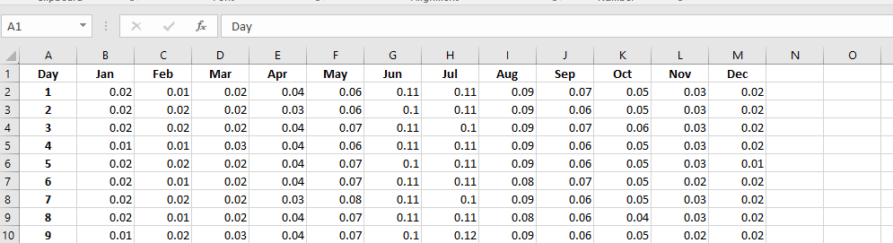
- Starting with highlighting section B2 through B32, copy the rain data in that column into the clipboard.
- Paste that data in the D2 section. It should fill out D2 through D32.
- Go back to the empty spreadsheet. Copy the February data C2 through C29. On the records.xlsm file, click on D33 and paste the data in. You’ll notice column A is the month number. Column B is the day of the month. So you can keep track of the dates.
  - Since there is a possibility of a leap year, you’ll need to manually enter in the data for February 29th. For cell C61, enter in the value from C60. For D61, enter in a zero.
- Repeat the copy and paste steps, copying the rain data from the empty sheet into the records.xlsm fields in column D to finish the rain for the year.
- Once completed, you no longer need the empty spreadsheet. It can be closed.
The purpose for my rain data is to first, calculate what the normal rainfall for the month is. On the first of the month, I like to see what I can expect for normal rainfall for the month is. That normal month value on my site stays the same for the whole month. Then I can compare my actual rainfall to the normal and see where I stand.
The second purpose is to calculate a year to date (YTD) normal rainfall amount. This value will change every day by the amount entered in the column D. The value in column F is then displayed on the site as Normal YTD rain to see where I stand for the year with rain amounts. So those are shown on my site like below:

If all you are looking for is rain data, you can skip the next sections on entering in the temperature data as you won’t be using them. This is what I do since I use the noaarec.php file to get my temperature data.

The next section is a lot more time intensive. The normal high and low temperatures can be copied and pasted in the same fashion as the rain data. But the record high and low temperatures need to be manually entered. We’ll start with the normal temperatures.
- On the same NOWData Site. Have your city highlighted in 1. Location.
  - Have “2. Product” set to “Daily/monthly normals”.
  - Set “3. Options” to Daily.
  - Change “Variable” to “Temperatures”.
  - Click on “4.View” Go.
- A window with a graph and table will appear. Scroll down to the “Max Temperature Normal” section. Highlight the section from upper left and “Day”, down to bottom right and the December 31st temperature. Click on CONTROL-C to copy that data into the clipboard.
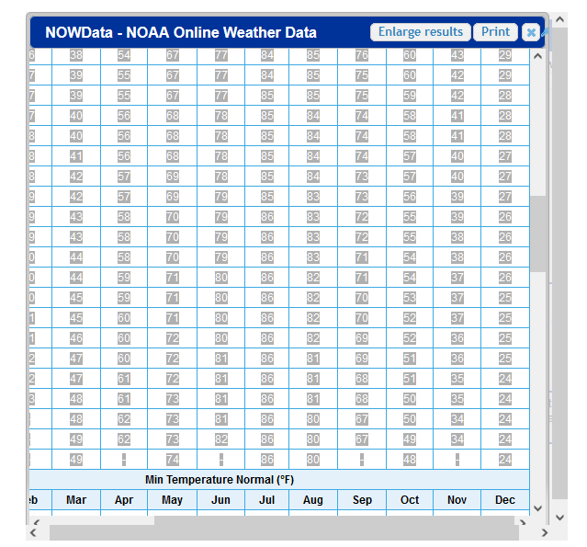

- Open a new blank spreadsheet. Hit CONTROL-V to paste the temperatures into the spreadsheet.
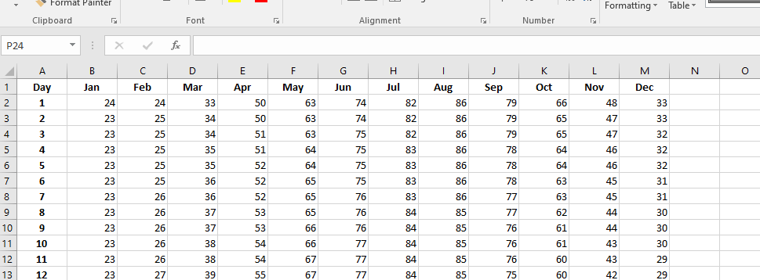
- In the blank spreadsheet, start by highlighting column section B2 through B32, click on CONTROL-C to copy that into the clipboard. This is your January normal high temperatures.
- Change to the records.xlsm. Click on cell K2. Hit CONTROL-V to paste the normal January highs in.
- Go back to the empty spreadsheet. Repeat the copy and paste for the other months, entering all the data into the K column. Again for leap year, you will need to make an adjustment for K61. Enter in the value for K60.
- Next, go back to the NOWData webpage. Scroll down to the Min Temperature Normal table. Repeat same procedure for the low temperatures, making an adjustment for February 29th and cells L61 and L60. Coping the data from the table and into your blank spreadsheet. Steps 2-6 above. This time you will work with column L for all of your low temperature data.
- At this point, columns K and L should have all of your daily normal high and low temperatures entered.
This last section is about entering into your spreadsheet the daily temperature and year it occurred. Due to some issues with PHP coding, the record high and the date the record high occurred, need to be in two different columns. The issue is that PHP doesn’t like the degree symbol inside of a TXT file. So I had to break the values out. So that is why columns G through J exist as four columns.
- Go back to the NOWData page.
  - Highlight your city in “1. Location”.
  - Change “2. Product” to “Calendar day summaries”
  - Leave “3. Options” to the full year range shown.
  - Change “Variable” to “Max Temp”
  - Change “Summary to “Daily Maximum”
  - Click on “Go” under “4.View”

- A table will appear. You can go through the same copy/paste procedure to copy the information into an empty spreadsheet. I highlighted only the number 1 at top left, to the last field for December 31st, then copied. When I pasted the data into a blank spreadsheet, my Excel did break apart the temperature and year. This made it easier to do the same copy/paste for all the data in columns G and H for record highs.
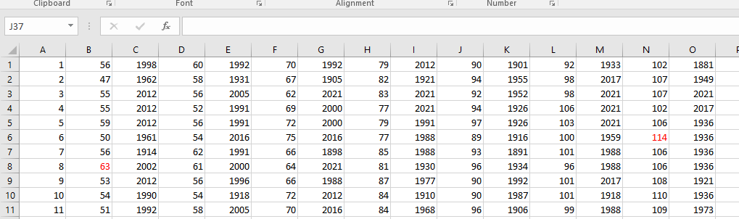

- Don’t worry if some colors creep into the cells. The export macro will ignore the colors.
- To gather the low data, repeat steps 2 and 3, changing the “Variable” section to “Min Temp”.
- Repeat steps 1 and 2, filling in the I and J columns.
- That should be it for filling out the temperature data.
The last item is updates. From when I began this spreadsheet, my rain data has only changed twice. So it doesn’t appear the NWS updates the rain data all that often. Maybe once every 4 years or so.
For the record temperature data, you could perform steps 2-4 and paste the data into blank spreadsheet. The do a CONTROL-F find function to search for the past year. You could probably just do the check once a year at the beginning of the year, and search for last year record changes and update the day appropriately.

Macros
I have created 8 macros. Each of these macros generate a TXT file. Click on the View tab, Macros button, View macros.
Rain:
RainMonth: This macro generates one TXT for each month of the year and contains the normal rain for the month. File format is “rain01mo.txt” for January rain. “rain02mo.txt” for February, and so on. 12 files total.
TYD_Rain: This macro generates one file per a day of the year and contains the normal year to date rain for that day of the year. The data is pulled from column G. It creates one file per a day of the year. 366 files to include leap day. File format is “0101ytd.txt” for January 1st. “0102ytd.txt” for January 2nd, and so on.

Temperature:
NormHi: This macro generates one file per a day of the year and contains the normal high temperature for that date. The data is pulled from column L. It creates one file per a day of the year. 366 files to include leap day. File format is “0101nh.txt” for January 1st normal high. “0102nh.txt” for January 2nd, and so on.
NormLow: This macro generates one file per a day of the year and contains the normal low temperature for that date. The data is pulled from column M. It creates one file per a day of the year. 366 files to include leap day. File format is “0101nl.txt” for January 1st normal high. “0102nl.txt” for January 2nd, and so on.
RecHiT: This macro generates one file per a day of the year and contains the record high temperature for that date. The data is pulled from column H. It creates one file per a day of the year. 366 files to include leap day. File format is “0101rh.txt” for January 1st normal high. “0102rh.txt” for January 2nd, and so on.
RecHiD: This macro generates one file per a day of the year and contains the record high temperature year for that date. The data is pulled from column I. It creates one file per a day of the year. 366 files to include leap day. File format is “0101rhd.txt” for January 1st normal high. “0102rhd.txt” for January 2nd, and so on.
ReclowT: This macro generates one file per a day of the year and contains the record low temperature for that date. The data is pulled from column J. It creates one file per a day of the year. 366 files to include leap day. File format is “0101rl.txt” for January 1st normal high. “0102rl.txt” for January 2nd, and so on.
ReclowD: This macro generates one file per a day of the year and contains the record low temperature year for that date. The data is pulled from column K. It creates one file per a day of the year. 366 files to include leap day. File format is “0101rld.txt” for January 1st normal high. “0102rld.txt” for January 2nd, and so on.
Lastly, after you’ve generated all of the text files, they will need to be uploaded into a folder named history in the root of your site. My following code will assume the location of the files is /history.

PHP Code for to display the TXT files:
- You will need to edit your ajaxdashboard.php file.
- If you are running the stock ajaxdashboard, scroll down to about line 1055. There will be a section relating to “end $haveSolar”. Below that you will be adding a table. If you have the alternate dashboard, you will still have this section. It’ll be further down than line 1055.
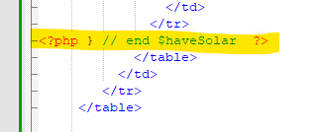
- Enter this new table into your document. It will appear below your live weather data, and above your forecast.
<table width="630" border="0" cellpadding="0" cellspacing="0" style = "font-weight: normal";>
<th style="text-align:center" colspan="2">National Weather Service History</th>
<tr style="text-align:center">
<td>Normal Rain Month: &nbsp;<?php $mydate = date('m'); $filename = "./history/rain".$mydate."mo.txt"; include($filename);?>&nbsp; in.</td>
<td>Normal Rain YTD: &nbsp;<?php $mydate = date('md'); $filename = "./history/".$mydate."ytd.txt"; include($filename);?>&nbsp; in.</td>
</tr>
<tr style="text-align:center">
<td>Normal High: &nbsp;<?php $mydate = date('md'); $filename = "./history/".$mydate."nh.txt"; include($filename);?>&deg;F</td>
<td>Normal Low: &nbsp;<?php $mydate = date('md'); $filename = "./history/".$mydate."nl.txt"; include($filename);?>&deg;F</td>
</tr>
<tr style="text-align:center">
<td>Record High: &nbsp;<?php $mydate = date('md'); $filename = "./history/".$mydate."rh.txt"; include($filename);?>&deg;F&nbsp;in&nbsp;<?php $mydate = date('md'); $filename = "./history/".$mydate."rhd.txt"; include($filename);?></td>
<td>Record Low: &nbsp;<?php $mydate = date('md'); $filename = "./history/".$mydate."rl.txt"; include($filename);?>&deg;F&nbsp;in&nbsp;<?php $mydate = date('md'); $filename = "./history/".$mydate."rld.txt"; include($filename);?></td>
</tr>
</table>

